

**DEPARTAMENTO DE ELETRÓNICA, TELECOMUNICAÇÕES E**

**INFORMÁTICA**

**LICENCIATURA EM ENG. DE COMPUTADORES E INFORMÁTICA**

REDES DE COMUNICAÇÕES 1

**LABORATORY GUIDE NO. 3**

# Objectives

* The Virtual LAN (VLAN) concept
* Analysis of the IEEE802.1Q VLAN protocol
* Interconnection of VLANs

# Duration

* 1 week



*Note: In GNS3, a Layer 2 switch can be implemented (i) with a basic device (Ethernet switch*

*device) that does not have console and does not support the Spanning Tree Protocol, or (ii) with a switching module in a router (EtherSwitch router device). This guide will use the latter,*

*EtherSwitch router as Layer 2 switch using only the switching module ports (e.g., F1/0 to F1/15).*



# Experiments with Virtual LANs – Mode Access and interfaces VLAN

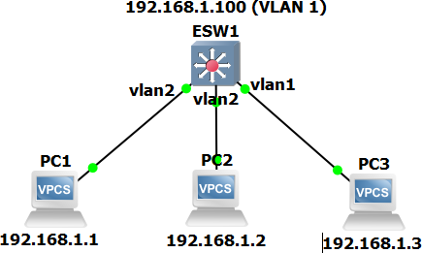

**Figure 1**

* 1. Set up the network shown in the figure above and configure all IP addresses with netmask 255.255.255.0. In Switch 1, check that the Spanning Tree protocol is disabled and configure two VLANs in the following way:
     1. Ports numbered F1/5 to F1/8 belonging to VLAN 2 (must be created):

## ESW1# vlan database ESW1(vlan)# vlan 2 ESW1(vlan)# exit

***ESW1# configure terminal ESW1(config)# interface range F1/5 - 8***

## ESW1(config-if-range)# switchport access vlan 2 ESW1(config-if-range)# end

***ESW1# write***

* + 1. all other ports belonging to VLAN 1 (the default/native VLAN)
    2. Configure an IP address for VLAN 1 and enable the VLAN

## ESW1# configure terminal ESW1(config)# interface vlan 1

***ESW1(config-if)# ip address 192.168.1.100 255.255.255.0 ESW1(config-if)# no shutdown***

## ESW1(config-if)# end ESW1# write

To verify the VLAN associated with each interface, use the command:

**ESW1# show vlan-switch**



* 1. Connect the PC1 and PC2 to VLAN 2 ports and PC3 to a VLAN 1 port, as shown in the figure
  2. From each equipment run the ping command to check which pairs of equipment (including Switch 1) have IP connectivity. Verify that only equipment in the same VLAN has IP connectivity.
  3. Using the switch console, verify the Forwarding Table of Switch 1:

## ESW1# show mac-address-table

Check that the VLAN information is in accordance with the network setup

* 1. Start captures on the links PC1-Switch1 and PC3-Switch1 and set an appropriate filter to display ARP and ICMP packets. Run the ping commands specified in the following table. For each run, register the connectivity and the filtered packets. Justify the results obtained on each case.

| **Ping from:** | **Ping to:** | **Connectivity (yes or no)** | **Packets**  **(PC1-Switch1 link)** | **Packets**  **(PC3-Switch1 link)** |
| --- | --- | --- | --- | --- |
| PC2 | Switch1 | no | arp req 192.168.1.100? mac | —---------------------- |
| PC2 | PC3 | no | arp request 192.168.1.3? mac | —---------------------- |
| PC2 | 192.168.1.34 | no | arp request 192.168.1.34? mac | —---------------------- |
| PC3 | Switch 1 | yes | —--------------- | arp req + rep + icmp |
| PC3 | PC2 | no | —--------------- | arp req 192.168.1.2? mac |
| PC3 | 192.168.1.34 | no | —--------------- | arp req 192.168.1.34? mac |
| Switch1 | PC3 | yes | —--------------- | arp req + rep + icmp |
| Switch1 | 192.168.1.34 | no | —--------------- | arp req 192.168.1.34? mac |

pc2 para o switch nao vai haver conexao porque o switch esta configurado apenas para a vlan 1

pc2 para pc3 nao ha conexao porque os pcs estao conectados a vlans diferentes  
pc2 para 192.168.1.34 nao responde porque o endereço não existe

pc3 para sw1 responde porque estao na mesma vlan

pc3 para pc2 nao responde porque estao em vlans diferentes

pc3 para 192.168.1.34 nao responde porque o endereço não existe

sw1 para pc3 responde porque estao na mesma vlan

sw1 192.168.1.34 nao responde pq o endereço nao existe

# Experiments with Virtual LANs – Mode Trunk and interconnection

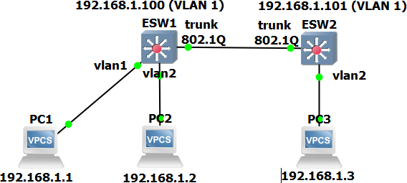

**Figure 2**

* 1. Reconfigure the network as specified in the figure above.
     1. In the new inserted Switch 2, configure VLANs 1 and 2 in the same way as specified to Switch 1 in the previous experiments.
     2. At both Switches 1 and 2, configure the ports connecting the switches as a trunk port (e.g., F1/15) in order to support both VLAN using the IEEE802.1Q VLAN protocol, as specified in the figure above.

## ESW(config)# interface F1/15 ESW(config-if)# switchport mode trunk

* 1. Start new capture on the link Swicth1-Switch2 and set an appropriate filter to display ARP and ICMP packets. Run the ping commands specified in the following table. For each run, register the filtered packets and their VLAN ID value. Justify the results obtained on each case.

| **Ping from:** | **Ping to:** | **Connectivity (yes or no)** | **Filtered packets** |
| --- | --- | --- | --- |
| PC1 | Switch 1 | yes | arp+icmp |arp req| —------ |
| PC1 | Switch 2 | yes | arp +icmp |arp+icmp| —----- |
| PC1 | PC2 | no | arp req|arp req|------ |
| PC1 | PC3 | no | arp req| arp req|----- |
| PC2 | Switch 1 | no | arp req 2|arp req 2|arp req 2 |
| PC2 | Switch 2 | no | arp req 2|arp req 2|arp req 2 |
| PC2 | PC1 | no | arp req 2|arp req 2|arp req 2 |
| PC2 | PC3 | yes | arp+icmp2|arp+icmp2|arp+icmp2 |

PC1 para Switch1: Uma vez que estao na mesma vlan conseguem se comunicar   
PC1 para Switch2: Como o PC1 e o ESW2 estão conectados trunk significa conectividade entre eles e os pacotes são transmitidos.

PC1 para PC2: PC1 e o PC2 estão em VLANs diferentes portanto não há ligação  
PC1 para PC3: PC1 e o PC3 estão em VLANs diferentes portanto não há ligação

PC2 para Switch1: PC2 e o Switch1 estão em VLANs diferentes portanto não há ligação  
PC2 para Switch2: PC2 e o Switch2 estão em VLANs diferentes portanto não há ligação  
PC2 para PC1: PC2 e o PC1 estão em VLANs diferentes portanto não há ligação  
PC2 para PC2: Uma vez que estao na mesma vlan conseguem se comunicar

**Format of the Ethernet frames with and without 802.1Q tags**

**Ethernet frame with 802.1Q tag**

| Destination Address (6 *bytes*) |
| --- |
| Source Address (6 *bytes*) |
| 8100h (2 *bytes*) |
| Priority (3 *bits*) |
| CFI (1 *bit*) |
| **VLAN ID (12 *bits*)** |
| Type / Length (2 *bytes*) |
| Data Field |

e

# Experiments with Virtual LANs – Routing between VLANs – External

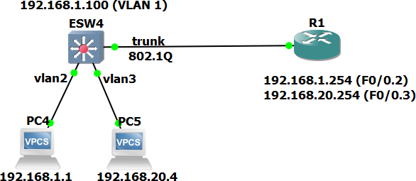

| **Ethernet frame without 802.1Q tag** |
| --- |
| Destination Address (6 *bytes*) |
| Source Address (6 *bytes*) |
| Type / Length (2 *bytes*) |
| Data Field |

**Figure 3**

* 1. Reconfigure the network as specified in the figure above where the Router routes packets between VLAN 2 and VLAN 3 (each one with its own network IP address).

In Switch 4, configure the VLAN in the following way:

* + 1. ports numbered F1/0 to F1/4 belonging to VLAN 3 (must be created);

## ESW1# vlan database ESW1(vlan)# vlan 3 ESW1(vlan)# exit

***ESW1(config)# interface range F1/0 - 4 ESW1(config-if-range)# switchport access vlan 3***

* + 1. ports numbered F1/5 to F1/8 belonging to VLAN 2;
    2. all other ports belonging to VLAN 1 (the default/native VLAN)
  1. In the Router, create 2 virtual interfaces on interface F0/0, one for VLAN 2 (F0/0.2) and another for VLAN 3 (F0/0.3), with the given IP addresses:

## Router (config)# interface F0/0 Router (config-if)# no shutdown Router (config-if)# interface F0/0.2

***Router (config-subif)# encapsulation dot1Q 2***

## Router (config-subif)# ip address 192.168.1.254 255.255.255.0 Router (config-if)# interface F0/0.3

***Router (config-subif)# encapsulation dot1Q 3***

## Router (config-subif)# ip address 192.168.20.254 255.255.255.0

* 1. In both PCs, configure the appropriate the IPv4 address and Default Gateway address. For PC4:

## PC-4> ip 192.168.1.1/24 192.168.1.254

* 1. To verify the correctness of the configurations, check the IP connectivity between PC4 and PC5 with the ping command. Register and justify the IP routing table of the Router.

Use the command to view the IPv4 routing table:

## Router# show ip route

* 1. Start new capture on the link Swicth1-Router and set an appropriate filter to display ARP and ICMP packets. Run the ping commands specified in the following table. For each run, register the filtered packets and their VLAN ID value. Justify the results obtained on each case.

| **Ping from:** | **Ping to:** | **Connectivity (yes or no)** | **Filtered packets** |
| --- | --- | --- | --- |
| PC4 | Switch 4 | não | ARP REQ |
| PC4 | Router | sim | ARP + ICMP |
| PC4 | PC5 | sim | ARP + ICMP |
| PC4 | 192.1.1.100 | sim | ARP + ICMP |
| PC5 | Switch 4 | sim | ARP + ICMP |
| PC5 | Router | sim | ARP + ICMP |
| PC5 | PC4 | sim | ARP + ICMP |
| PC5 | 192.1.1.100 | não | ARP REQ |

PC4 para Switch4: Estão em VLANs diferentes logo não ha conecção  
PC4 para Router: Comunicam porque o PC4 está na VLAN2 e o router tem uma subinterface configurada para essa VLAN (192.168.1.254)  
PC4 para PC5:Exite conecção uma vez que o router faz o roteamento inter-VLAN, permitindo que os dois PCs comuniquem um com o outro  
PC4 para 192.1.1.100: Estão em VLANs diferentes logo não ha conecção  
PC5 para Switch4: Estão em VLANs diferentes logo não ha conecção  
PC5 para Router:Comunicam porque o PC5 está na VLAN3 e o router tem uma subinterface configurada para essa VLAN (192.168.20.254)  
PC5 para PC4: Exite conecção uma vez que o router faz o roteamento inter-VLAN, permitindo que os dois PCs comuniquem um com o outro  
PC5 para 192.1.1.100: Estão em VLANs diferentes logo não ha conecção

# Experiments with Virtual LANs – Routing between VLANs – Internal

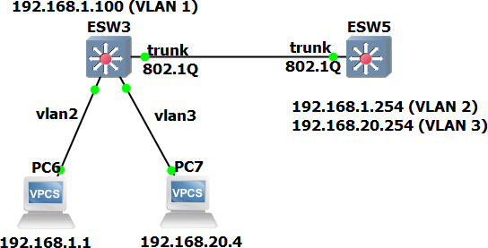

**Figure 4**

The previous network connectivity can be implemented using internal routing between VLANs within the L3 Switch.

In Vlans 2 and 3, configure the right IP address which will be used as gateways.

As in the previous scenario with the router sub-interfaces, with the L3 Switch we may also support different VLANs over the same connection:

## ESW5# vlan database ESW5(vlan)# vlan 2

***ESW5(vlan)# vlan 3 ESW5(vlan)# exit***

## ESW5(config)# interface vlan 2

***ESW5(config-if)# ip address 192.168.1.254 255.255.255.0 ESW5(config-if)# no shutdown***

## ESW5(config)# interface vlan 3

***ESW5(config-if)# ip address 192.168.20.254 255.255.255.0 ESW5(config-if)# no shutdown***

***ESW5(config)# interface F1/15 ESW5(config-if)# switchport mode trunk***

# A screenshot of a computer Description automatically generatedA screenshot of a computer Description automatically generatedAnnex A

**Introduction to the ESW Cisco Switch Router (L3 Switch)**

If you still do not have, you must add the ESW to your GNS installation, under Edit 🡺 Preferences

🡺 Dynamips 🡺 IOS Routers 🡺 New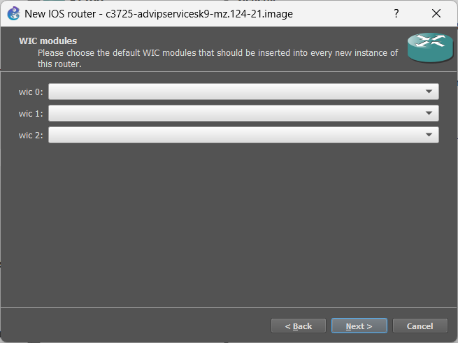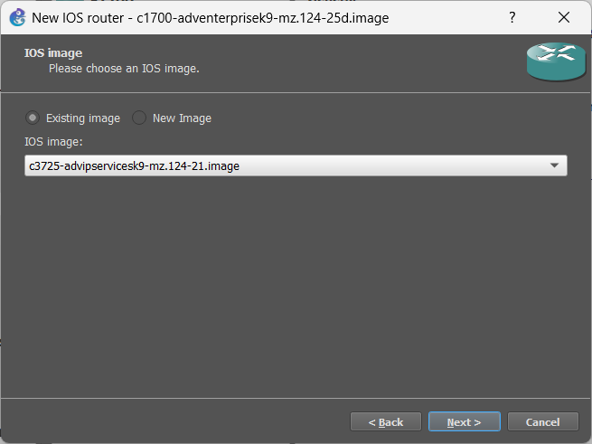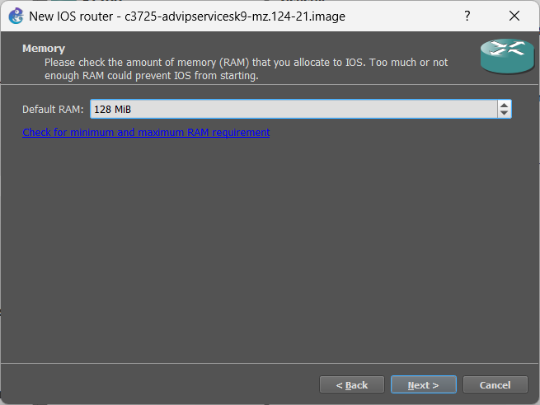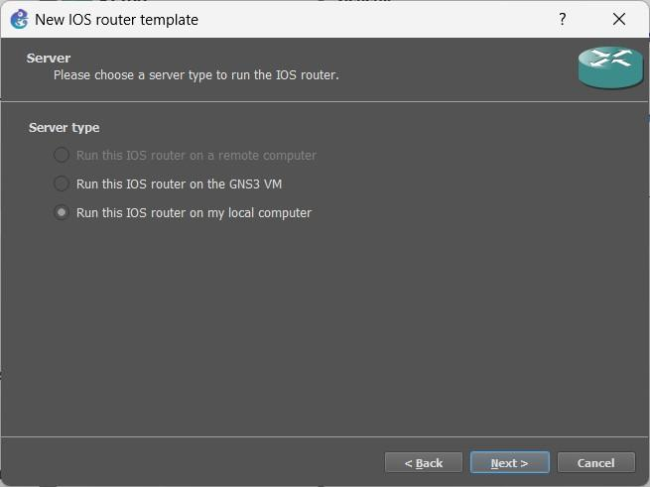

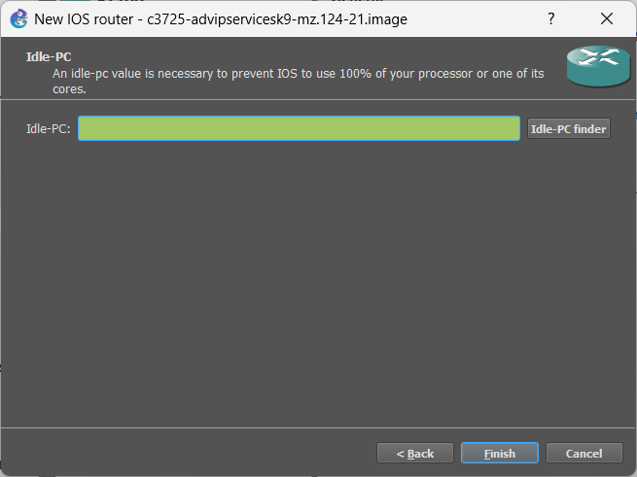 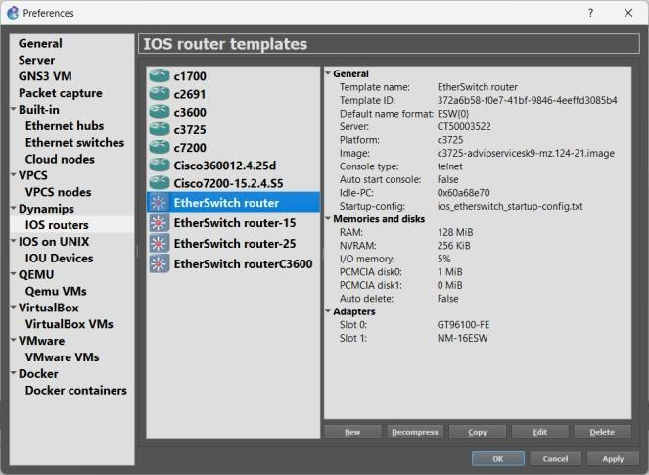

Create a new project for the VLANs Guide and add an EtherSwitch router (ESW1):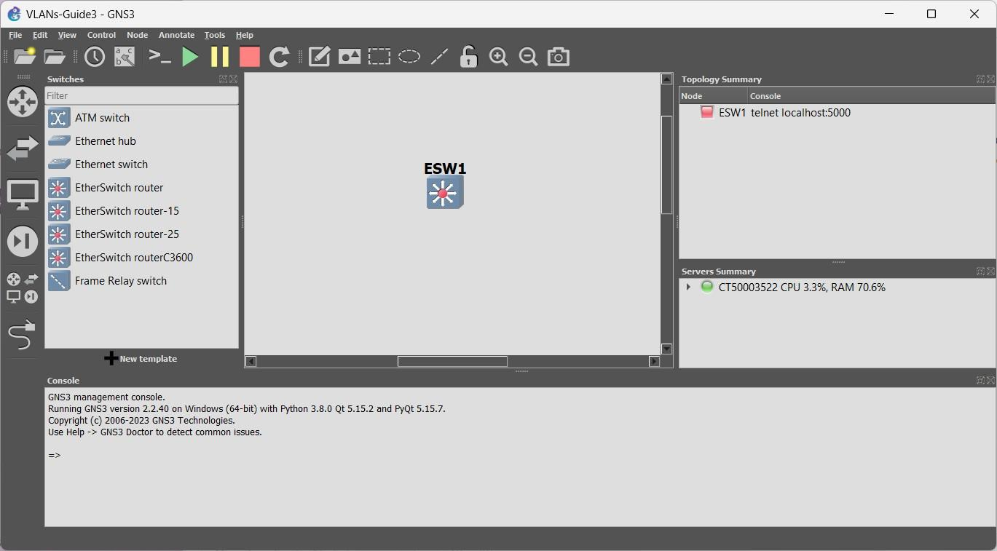

Start the device and right click over it to open the console: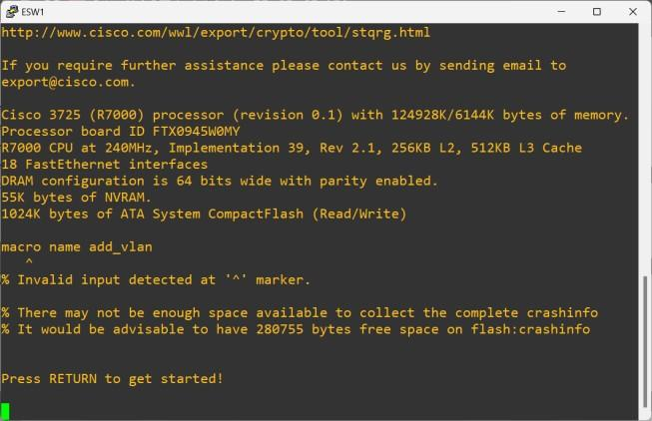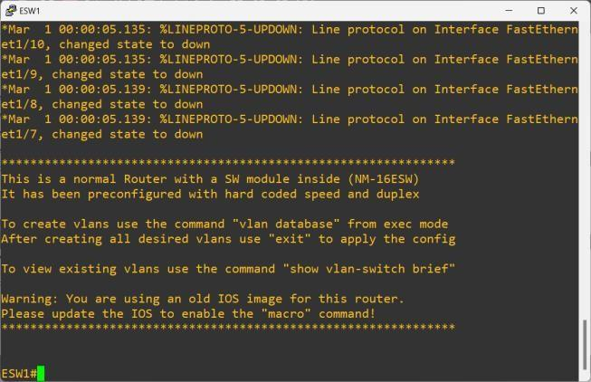

Do a show run to check its configuration, with special attention to the available interfaces.

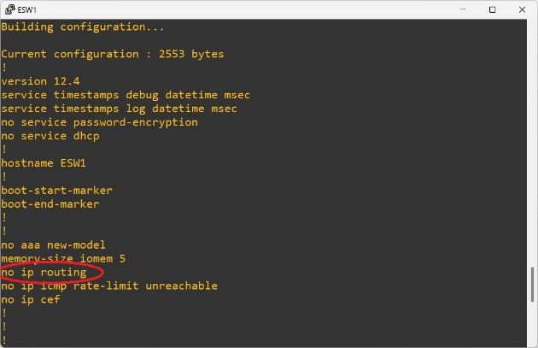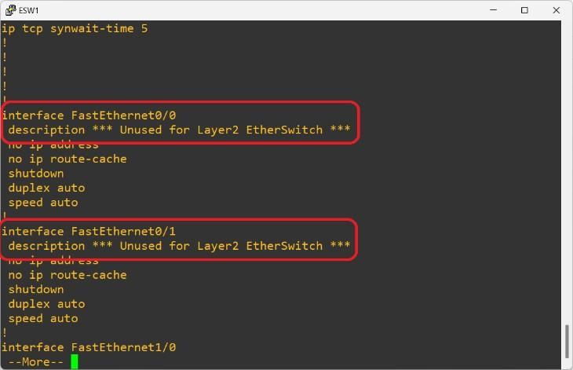

Note that:

* By default, this device will not work as a router. You will need to enable the routing engine.
* There are two interfaces (F0/0 and F0/1) that are ROUTING interfaces only. They should NOT BE USED for switching purposes.

There are 16 interfaces (from F1/0 to F1/15) that “belong” to a switch card interface on the router, and these are the interfaces used for switching and VLANs.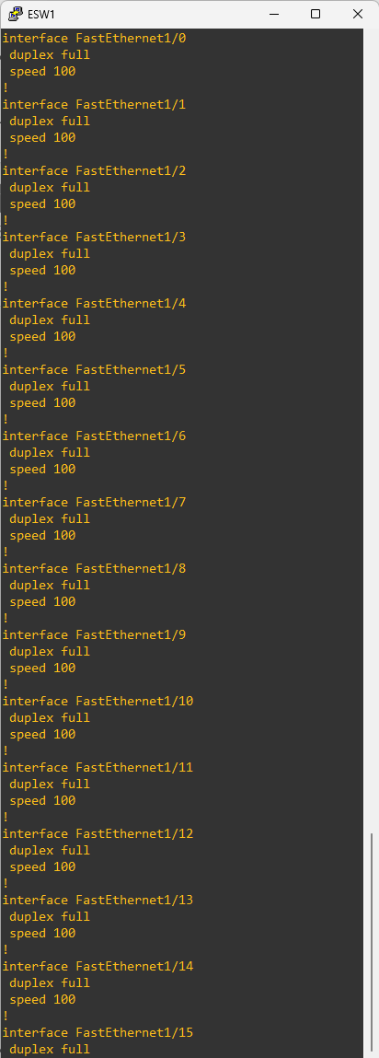

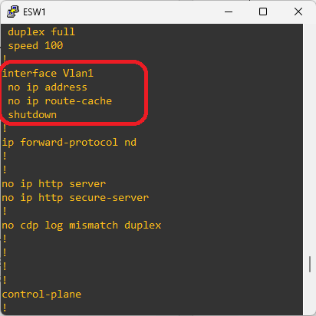

By default there is a Vlan1 interface, through which all switch ports belonging to the Vlan1 may do routing to the other routing interfaces (F0/0 and F0/1). Note that this interface is in “shutdown” by default. In order to be used, you have to do the “no shutdown” to it.

In order to have more Vlan interfaces, they must be added to the Vlan database according to the needs: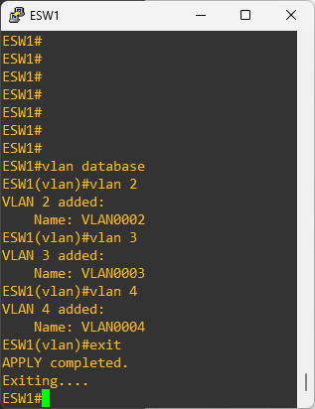

Enabling IP Routing functions on this device:

Note: for IPv6 the same thing must be done. “ESW1(config)#ipv6 unicast-routing”

Putting a switch port in access mode and associating it to a specific VLAN: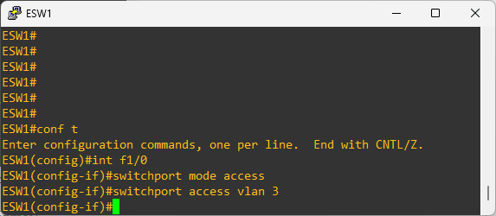

Applying the same configuration to a range of interfaces (F1/4, F1/5, F1/6 and F1/7):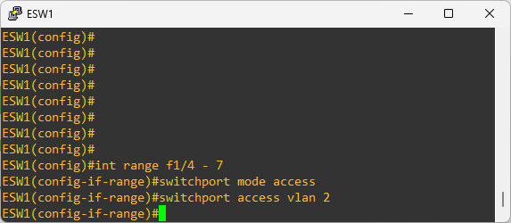

Putting a port in TUNK mode and allowing all configured VLANs to be able to come in and out of that interface (you may restrict the port to some specific interfaces, if needed):

Note:

* Ports on access mode can only belong to one specific VLAN and the incoming and outgoing Ethernet frames DO NOT have VLAN TAG.
* Ports on trunk mode may input and output Ethernet frames from different VLANs and those Ethernet frames SHOULD BE TAGGED.

In order to have routing between VLANs, and Interface VLAN should be created and configured for each VLAN: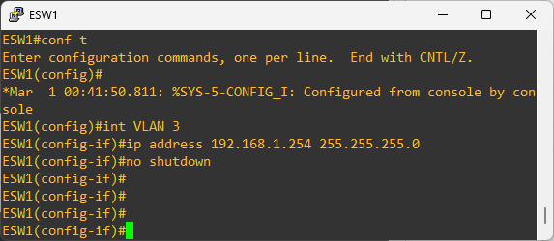

IMPORTANT: DUE TO A LIMITATION OF GNS3 WHEN USING THIS IOS AS A L3 SWITCH, AFTER THE VLANS AND INTERFACES ARE CONFIGURED, IT IS NECESSARY TO WRITE THE CONFIGURATION (ESW#write) AND AFTER THAT, STOP AND START AGAIN THE L3 SWITCH.

**Configuring a regular router interface to send and receive Ethernet frames with**

**VLANs**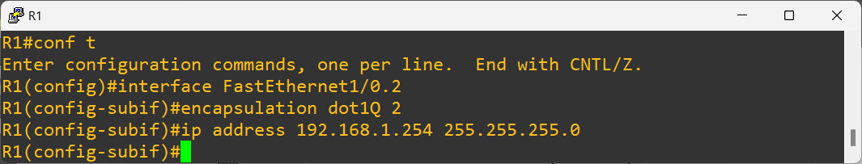

Note that a sub-interface was created (F1/0.2), belonging to the physical interface F1/0.

We then configured this sub-interface to send and receive tagged frames (with the command

“encapsulation dot1Q” followed by the VLAN ID we want to use on this sub-interface)

We may add more sub-interfaces to the same physical interface (e.g. F1/0.3, F1/0.450, etc). The ID of the interface “.3”, “.450” may be different from the VLAN ID we want to use on that sub-interface:

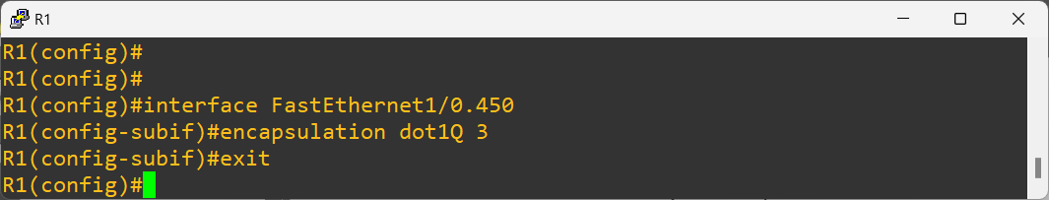

To be able to use these sub-interfaces, the “mother” interface must be enabled: